Project Name |  | Confidentiality Level
XX Project |  | For Recipients’ Reference Only
Project ID | Version | Document Code

XX Software Requirements Specification



Copyright © Ruankosoft Technologies(Shenzhen), Co., Ltd.
. All Rights Reserved
Revision Record
Date | Revision Version | CR ID /Defect ID | Sec No. | Change Description | Author
Content
1 Introduction 6
1.1 Purpose 6
1.2 Scope 6
2 General description 6
2.1 Software perspective 6
2.1.1 About the Project 6
2.1.2 Environment of Product 6
2.2 Software function 6
2.3 Actors 6
2.4 User characteristics 6
2.5 Assumptions & Dependencies 7
2.6 System Use Case 7
2.7 Sub-module Functional Requirements 1 7
2.7.1 Functional Requirements1 7
2.7.2 Functional Requirements2 8
2.8 Sub-module Functional Requirements2 9
2.8.1 Functional Requirements1 9
2.8.2 Functional Requirements2 9
2.9 Data Information 9
3 Interface Requirements 9
3.1 User Interface 9
3.2 Software Interface 10
4 Overall Design Constraints 10
4.1 Hardware Limitations 10
4.2 Technology Limitations 10
5 Software Quality Attributes 10
6 Requirements Classification 10

Keywords: Words that will reflect main contents of the document.
Abstract: 合同
List of abbreviations:
Abbreviations | Full spelling | Chinese explanation

Introduction

Purpose
该需求规格说明书是关于合同管理系统的功能需求和性能需求的描述，该说明书的预期 读者为： 用户； 项目管理人员； 测试人员； 设计人员； 开发人员。
描述了合同管理和权限管理两个模块的功能需求，明确所要开发的软件应具有的功 能、性能与界面，使系统分析人员及软件开发人员能清楚地了解用户的需求。

Scope
描述了功能，数据字典，接口，不包含系统的具体设计内容。

General description

Software perspective
系统采用 B/S 结构，服务器端需要配置程序的运行环境（JDK1.6）、安装 MySQL 数据， 用户端只需要通过浏览器就可以访问该网站。

Software function
系统分为六个模块：注册、登录、合同管理、查询统计、基础数据管理、系统管理。 系统功能结构图如下：
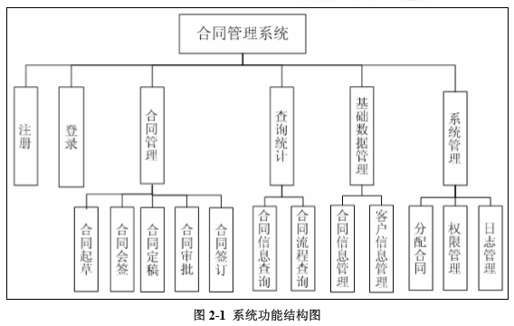 各模块下的功能描述如下： 1、注册模块 用户访问系统，可进行注册成为系统的合同操作员或合同管理员，注册成功进入登录页 面。
2、登录模块
(1) 登录：已注册的用户根据其拥有的不同角色，可以登录到不同页面，合同管理员角 色的用户，登录成功后转向管理员操作页面；合同操作员角色的用户，登录成功后转向到操 作员页面。
(2) 注销登录：点击操作页面的“注销登录”超链接，清除用户登录状态，返回到登录 页面。
3、合同管理模块
(1) 起草合同 用户登录后以合同操作员的身份进行合同的起草，填写合同名称（填写的信息不能为 空）、客户名称、开始时间、合同内容以及上传合同附件（doc、jpg、jpeg、png、bmp 或 gif 格式文件）。成功起草合同后，等待合同管理员对该合同进行人员分配。
(2) 会签合同 合同分配后，当涉及的会签人员登录合同管理系统后，点击其中的待会签合同，显示待 会签合同列表，可以选择一个合同打开后审阅合同内容。然后在会签处，填写会签意见，完 成会签工作。
(3) 定稿合同 合同起草人可以随时在系统中查询，是否所有的会签参与人员都已经完成会签。当所有
人员的会签完成后，起草人可根据会签意见结合签约方的意见对合同进行修改并定稿，修改 完成后提交审批。
(4) 审批合同 合同定稿完成后，由审批人进行审批，审批人也是由合同管理员指定，只有审批通过后， 才能进行合同签订操作。
(5) 签订合同 合同审批完成并且通过后，由合同起草人打印出正式合同，送双方签订。签订人根据实 际签订情况，录入合同签订信息，即完成了合同签订的流程。
4、查询统计模块 (1) 合同信息查询 管理员在合同查询界面上，对合同基本信息的查询，如根据合同编号、名称等进行查询。 以上的查询中，所有的字符串操作，都支持模糊匹配查询，这样，可以十分方便地通过 录入“只言片语”，搜索出尽可能详尽的结果。
(2) 合同流程查询 管理员可以查看任意合同已经到达合同流程的哪一个环节，合同起草者可以查看本人起 草的合同已经到达合同流程的哪一个环节。合同的会签人员可以看到待自己会签的合同列 表。
5、基础数据管理模块 (1) 合同基本信息管理 对合同的新增（起草合同），查询（合同基本信息）、修改（定稿合同）、删除。
(2) 客户基本信息管理 管理员进入系统后，在客户信息管理界面上，能够手工录入客户信息，并可进行客户查 询。可以选择各种条件进行组合查询。可以选择的条件有：合同编号、客户编号、客户名称 等等。
6、系统管理模块 (1) 分配合同 管理员登录后，查看起草完成的合同信息，确定合同内容无误后，指定参与会签、审批、 签订的人员。
(2) 权限管理 合同管理系统的用户及权限管理，分为合同管理员、合同操作员、新用户三级。 在权限管理上，根据用户角色划分权限，可以灵活地划分用户权限。 根据功能操作，系统可操作的功能模块包括起草合同、定稿合同、查询合同、删除合同、 会签合同、审批合同、签订合同、分配会签、分配审批、分配签订、流程查询、用户管理、 角色管理、基础信息维护等各种操作。
(3) 日志管理
用户在系统中的操作，如涉及到数据的增加、删除或更改，应建立日志，记录其姓名、 用户名、操作日期时间；如果管理员增加、删除用户或增加、取消用户的权限，应记录操作 的日期时间；管理员可以查阅日志，并进行备份和导出转存等。

User characteristics
1、管理员：对系统进行管理，有最高权限。 管理员进行系统维护、权限分配和合同流程配置之类的权限。对业务操作只能查询不能 对自己授予业务继续新增、修改、删除等操作。 可以根据需要进行管理员权限的细化，如设计系统管理员专门进行系统权限的管理，设 计合同管理员进行合同流程配置和跟踪等。
2、合同操作员：负责合同操作流程的管理，并可以跟踪合同的不同阶段。
3、新用户：没有任何权限，等待合同管理员分配权限.

Assumptions & Dependencies
本系统使用 Java 语言进行开发的，采用 MySQL 进行数据的存储，系统采用 B/S 结构， 用户只需要通过浏览器就可以访问网站。

System Use Case
Describe the system use case.

Sub-module Functional Requirements 1
This section describes how the input of the software is translated to the output. It describes the essential action the software must perform.
1. Sub-module introduction
Introduce sub-module.

2. Sub-module use case diagram
Describe the functions of the sub-module. Can describe with use case diagram.

Functional Requirements1
For each kind of function, or each independent function in some cases, the requirements of input, process and output must be described, which are usually organized with the following four subsections:

1. Introduction
<Itemize the detailed functional requirements associated with this feature. These are the software capabilities that must be present in order for the user to carry out the services provided by the feature. Include how the project should respond to anticipated error conditions or invalid inputs. Requirements should be concise, complete, unambiguous, verifiable, and necessary. Use "TBD" as a placeholder to indicate when necessary information is not yet available. >
2. Inputs
This section consists of:
A. Detailed description of all input data of the function, including:
Source of input
Quantify
Measurement units
Timing requirements
Valid input range that contains the precision and tolerance
B. Reference of interface specification or interface control document that are provided in proper place.
3. Process
Describes all the operations on the input data, and the process to get the output data, including the following specifications:
A. Verification of input data
B. Exact order of the operations, including the time sequene of each event.
C. Response to exception, such as:
Overflow
Communication failure
Error process
D. Any method used to transfer the input data to the output data. (such as equation, mathematic algorithm and logical operation)
For example.
The formula to calculate the income tax in a pay roll.
The weather model used for weather forecast
E. Verification of output data.

4. Output
This section should include:
A. The detailed description of output data of the function, including:
Target to output to (Such as a printer or a file)
Quantity
Measurement units
Time sequence
Valid output range including the precision and tolerance
Process of the invalid value.
Error message.
B. Reference of interface specification or interface control document that are provided in proper place.
For the systems with their requirements focused on the input/output actions, all the important input/output actions and the time sequences of the input/output pairs should be described in the SRS. In a system that inputs and actions are memorized as the basis for the reactions to be taken, the timing sequence for the input/output pairs must be available here. This kind of functional action is similar to a status machine.

Functional Requirements2
1. Introduction

2. Inputs

3. Process

4. Output

Sub-module Functional Requirements2

Functional Requirements1
1. Introduction

2. Inputs

3. Process

4. Output

Functional Requirements2
1. Introduction

2. Inputs

3. Process

4. Output

Data Information
Describe the data information of the system.

Interface Requirements

User Interface
A. Features that must be supported by the software for each man-machine interface. For example, if the user operates from a display terminal, then the following should be included:
Screen format required
Page layout and content of report and menu
Timing sequence for input and output
Usage of some functional key combinations
B. Every aspect about the use of the system's user interface. It could be a list that shows the user what should do and what should not do. For example, an option of overlong or overshort message. . And same as other requirements, these requirements should be easily verified. For example, saying "A level 4 typist can finish function X in Z minutes after a one-hour training." instead of "A typist can finish function X"

Software Interface
Describes how to use the other (required) software products. (such as data management system, operation system, or algorithm tools package), and the interfaces to other application systems (such as interfaces between the protocol process system and the database management system )

Overall Design Constraints

Hardware Limitations
This subsection could include Requirements for the software to operate inside various hardware constraints, such as timing constraints, memory constraints etc.)

Technology Limitations
This subsection could include limitations on the use of specific technologies, interfaces, databases, parallel operations; communications protocols; design conventions or programming standards.

Software Quality Attributes
Specify any additional quality characteristics for the project that will be important to either the customers or the developers. Some to consider are: adaptability, availability, correctness, flexibility, interoperability, maintainability, portability, reliability, reusability, robustness, testability, and usability. Write these to be specific, quantitative, and verifiable when possible. At the least, clarify the relative preferences for various attributes, such as ease of use over ease of learning.

Requirements Classification
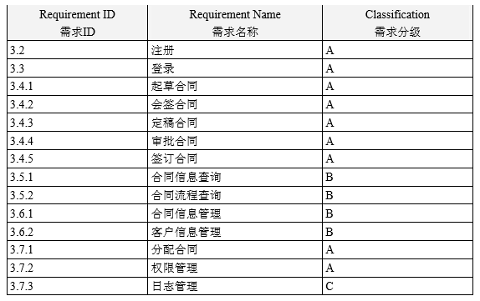
Importance of requirements is classified as following:
A. Mandatory: absolutely essential features, without which the product development will be canceled.
B. Important: unessential features that may affect the viability of the product.
C. Nice to have: desired features, the absence of which will not affect the product viability.

